Ordinal Number Determiners

🔹 What Are Ordinal Number Determiners?
# Source: AI Source: Provided by: [Data Path: Persons Table -> ID Column: 1, Name_En Column: Motasem Essam] -> From: [Chatgpt (GPT-4-turbo)] on [7/28/2025]
Ordinal Number Determiners are determiners that show the position or order of something in a sequence.
They answer “Which one?”, not “How many?”

✅ Common Ordinal Numbers:
# Source: AI Source: Provided by: [Data Path: Persons Table -> ID Column: 1, Name_En Column: Motasem Essam] -> From: [Chatgpt (GPT-4-turbo)] on [7/28/2025]
- first
- second
- third
- fourth
- fifth
- last
- next
- previous

✅ Why They're Determiners:
# Source: AI Source: Provided by: [Data Path: Persons Table -> ID Column: 1, Name_En Column: Motasem Essam] -> From: [Chatgpt (GPT-4-turbo)] on [7/28/2025]
They come before a noun to modify it directly — just like other determiners — and indicate order, not quantity.

✅ Examples in Sentences:
# Source: AI Source: Provided by: [Data Path: Persons Table -> ID Column: 1, Name_En Column: Motasem Essam] -> From: [Chatgpt (GPT-4-turbo)] on [7/28/2025]
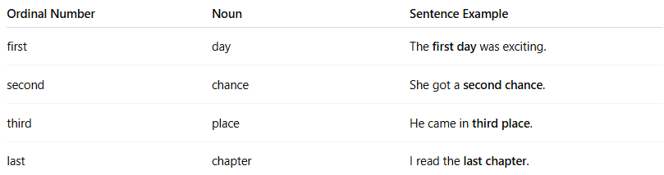
Ordinal Number | Noun | Sentence Example
first | day | The first day was exciting.
second | chance | She got a second chance.
third | place | He came in third place.
last | chapter | I read the last chapter.

🔁 Difference from Cardinal Numbers:
# Source: AI Source: Provided by: [Data Path: Persons Table -> ID Column: 1, Name_En Column: Motasem Essam] -> From: [Chatgpt (GPT-4-turbo)] on [7/28/2025]

Cardinal (How many?) | Ordinal (Which one?)
I have three pens. | This is the third pen.
We ate two cookies. | She took the second cookie.

